Lesson 25. Triển khai dự án Full Stack thực tế
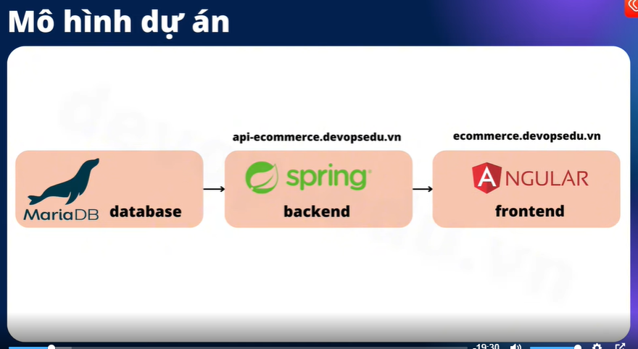
- Tạo 1 server gồm tối thiểu 1 GB, 1 CPU, 20 GB
5 apt update -y
6 apt install mariadb-server
=> Update va cai mariadb
root@database-server:~# vi /etc/mysql/mariadb.conf.d/50-server.cnf => mo file de ben ngoai co the truy cap vao
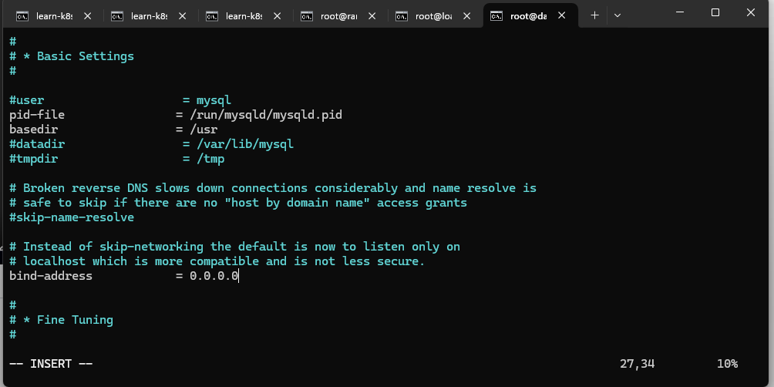
- Sua phan bind-address de ben ngoai co the truy cap duoc
root@database-server:~# systemctl restart mariadb => restart lai
root@database-server:~# mysql
Welcome to the MariaDB monitor. Commands end with ; or \g.
Your MariaDB connection id is 31
Server version: 10.6.22-MariaDB-0ubuntu0.22.04.1 Ubuntu 22.04

Copyright (c) 2000, 2018, Oracle, MariaDB Corporation Ab and others.

Type 'help;' or '\h' for help. Type '\c' to clear the current input statement.

MariaDB [(none)]> show database;
ERROR 1064 (42000): You have an error in your SQL syntax; check the manual that corresponds to your MariaDB server version for the right syntax to use near 'database' at line 1
MariaDB [(none)]> show databases;
+--------------------+
| Database |
+--------------------+
| information_schema |
| mysql |
| performance_schema |
| sys |
+--------------------+
4 rows in set (0.001 sec)
- Dang nhap vao dockerhub
- Keo file Fullstack-Ecommerce.zip sang ben server root
- Unzip roi cd roi build :D
root@database-server:/projects/Fullstack-Ecommerce-Web/03-frontend_angular-ecommerce# docker login => login vao docker hub
root@database-server:/projects/Fullstack-Ecommerce-Web/03-frontend_angular-ecommerce# docker tag ecommerce-frontend:v1 huyquyet1457/ecommerce-frontend:v1 => doi ten sao cho giong voi username

apiVersion: apps/v1
kind: Deployment
metadata:
labels:
app: ecommerce-frontend-deployment
name: ecommerce-frontend-deployment
namespace: ecommerce-frontend
spec:
replicas: 3
revisionHistoryLimit: 10
selector:
matchLabels:
app: ecommerce-frontend-deployment
strategy:
rollingUpdate:
maxSurge: 25%
maxUnavailable: 25%
type: RollingUpdate
template:
metadata:
labels:
app: ecommerce-frontend-deployment
namespace: ecommerce-frontend
spec:
containers:
- image: huyquyet1457/ecommerce-frontend:v1
imagePullPolicy: Always
name: ecommerce-frontend
ports:
- containerPort: 80
name: tcp
protocol: TCP
---
apiVersion: v1
kind: Service
metadata:
name: ecommerce-frontend-clusterip
namespace: ecommerce-frontend
spec:
internalTrafficPolicy: Cluster
ipFamilies:
- IPv4
ipFamilyPolicy: SingleStack
ports:
- name: tcp
port: 80
protocol: TCP
targetPort: 80
selector:
app: ecommerce-frontend-deployment
sessionAffinity: None
type: ClusterIP
---
apiVersion: networking.k8s.io/v1
kind: Ingress
metadata:
name: ecommerce-frontend-ingress
namespace: ecommerce-frontend
spec:
ingressClassName: nginx
rules:
- host: ecommerce.learnk8s.vn
http:
paths:
- backend:
service:
name: ecommerce-frontend-clusterip
port:
number: 80
path: /
pathType: Prefix

- Add file yaml vao
root@database-server:/projects/Fullstack-Ecommerce-Web/02-backend_spring-boot-rest-api# vi src/main/resources/application.properties => sua config
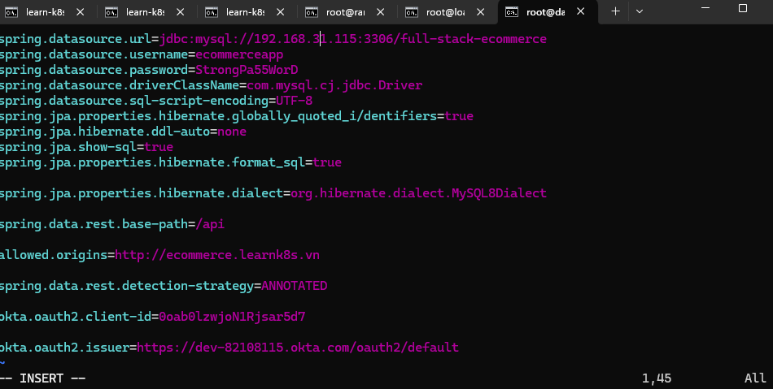

- Truy cap vao thu muc 01 de set db => root@database-server:/projects/Fullstack-Ecommerce-Web# cd 01-starter-files_db-scripts/
- root@database-server:/projects/Fullstack-Ecommerce-Web/01-starter-files_db-scripts# pwd && ls => de lay pass
- vao mysql => root@database-server:/projects/Fullstack-Ecommerce-Web/01-starter-files_db-scripts# mysql
- MariaDB [(none)]> source /projects/Fullstack-Ecommerce-Web/01-starter-files_db-scripts/01-create-user.sql
- MariaDB [(none)]> source /projects/Fullstack-Ecommerce-Web/01-starter-files_db-scripts/02-create-products.sql
- MariaDB [full-stack-ecommerce]> source /projects/Fullstack-Ecommerce-Web/01-starter-files_db-scripts/03-refresh-database-with-100-products.sql
- MariaDB [full-stack-ecommerce]> source /projects/Fullstack-Ecommerce-Web/01-starter-files_db-scripts/04-countries-and-states.sql
- MariaDB [full-stack-ecommerce]> source /projects/Fullstack-Ecommerce-Web/01-starter-files_db-scripts/05-create-order-tables.sql

apiVersion: apps/v1
kind: Deployment
metadata:
labels:
app: ecommerce-backend-deployment
name: ecommerce-backend-deployment
namespace: ecommerce
spec:
replicas: 2
revisionHistoryLimit: 10
selector:
matchLabels:
app: ecommerce-backend-deployment
strategy:
rollingUpdate:
maxSurge: 25%
maxUnavailable: 25%
type: RollingUpdate
template:
metadata:
labels:
app: ecommerce-backend-deployment
namespace: ecommerce
spec:
containers:
- image: huyquyet1457/ecommerce-backend:v1
imagePullPolicy: Always
name: ecommerce-backend
ports:
- containerPort: 8080
name: tcp
protocol: TCP
---
apiVersion: v1
kind: Service
metadata:
name: ecommerce-backend-clusterip
namespace: ecommerce
spec:
internalTrafficPolicy: Cluster
ipFamilies:
- IPv4
ipFamilyPolicy: SingleStack
ports:
- name: tcp
port: 80
protocol: TCP
targetPort: 8080
selector:
app: ecommerce-backend-deployment
sessionAffinity: None
type: ClusterIP
---
apiVersion: networking.k8s.io/v1
kind: Ingress
metadata:
name: ecommerce-backend-ingress
namespace: ecommerce
spec:
ingressClassName: nginx
rules:
- host: api-ecommerce.learnk8s.vn
http:
paths:
- backend:
service:
name: ecommerce-backend-clusterip
port:
number: 8080
path: /
pathType: Prefix

Bài 26: Config map K8s.
- Config map là để map cấu hình và config vào trong K8s, là cấu hình để lưu trữ dữ liệu kiểu key – value hoặc là file. Mục đích chính là tách riêng dữ liệu khỏi container app
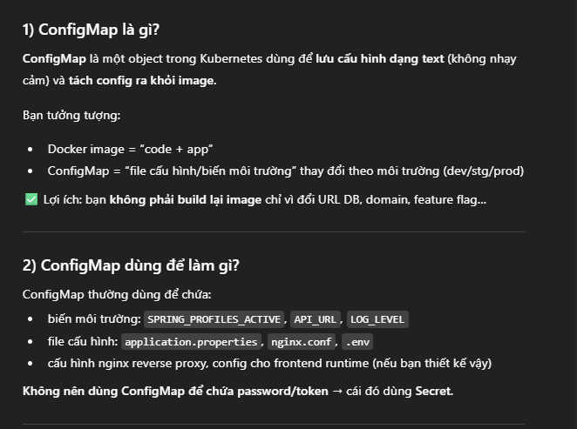
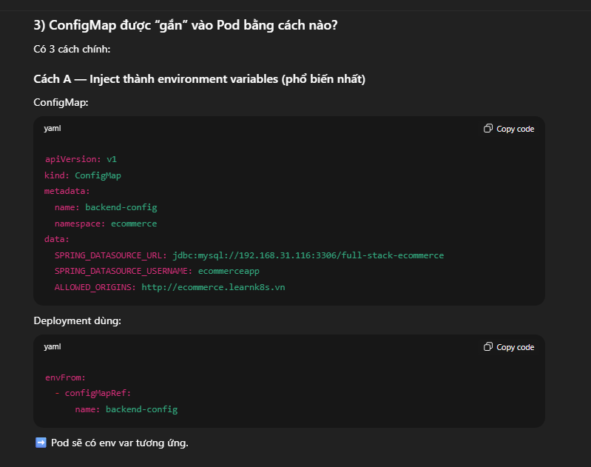
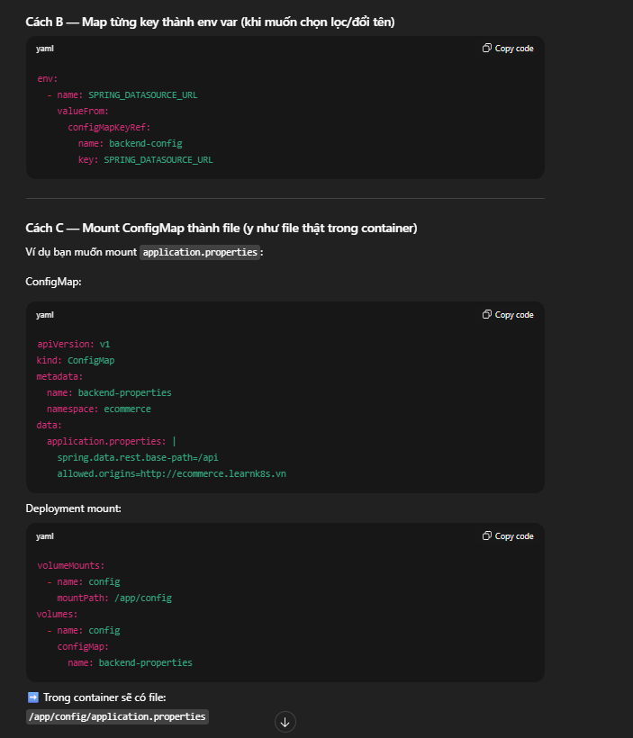
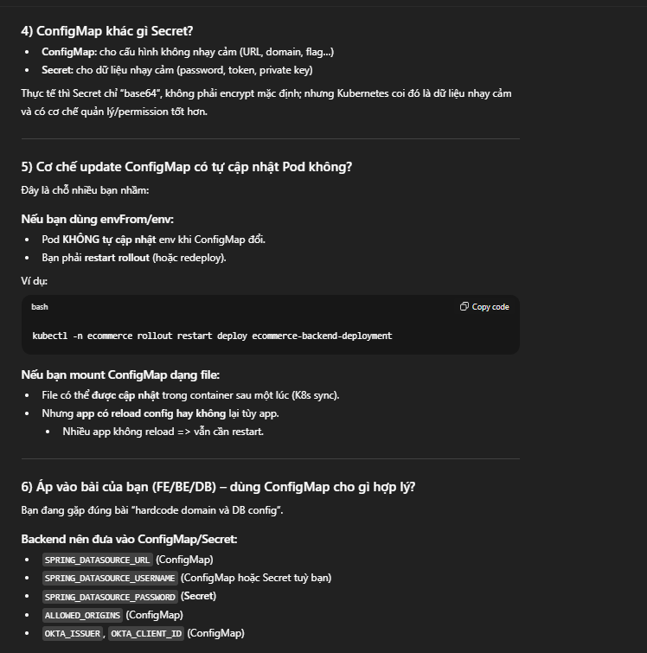

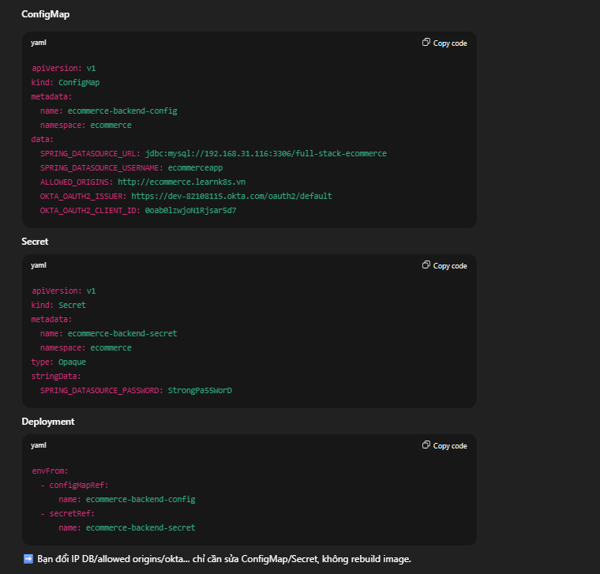

- Vao folder Project backend, sua file Docker file:
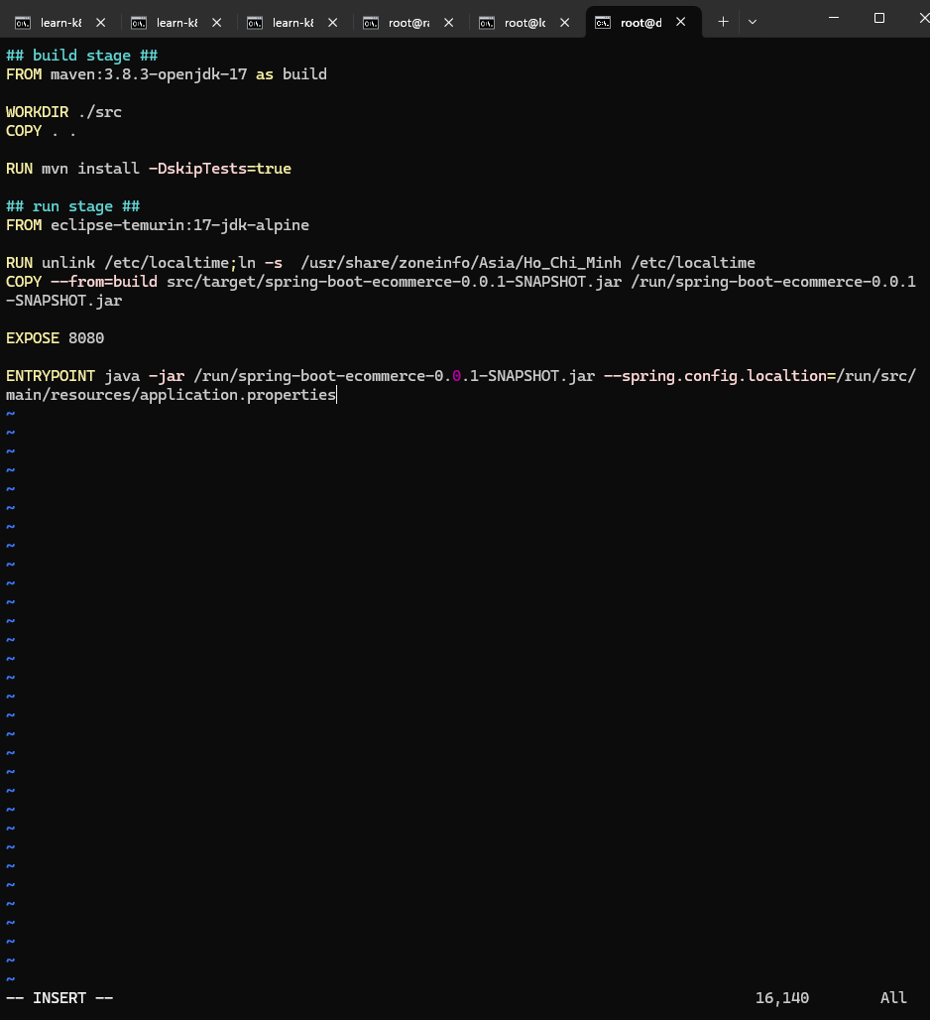
- ENTRYPOINT java -jar /run/spring-boot-ecommerce-0.0.1-SNAPSHOT.jar --spring.config.localtion=/run/src/main/resources/application.properties => /run/src/… chinh la nam trong container => khong lien quan den thu muc ben ngoai server
=> tao 1 config map voi noi dung file cau hinh cua application.properties => map vao trong container de co the doc file cau hinh
- root@database-server:/projects/Fullstack-Ecommerce-Web/02-backend_spring-boot-rest-api# docker build -t huyquyet1457/ecommerce-backend:v2 .
- root@database-server:/projects/Fullstack-Ecommerce-Web/02-backend_spring-boot-rest-api# docker push huyquyet1457/ecommerce-backend:v2 => push len
- Tao config map => chua duoc map vao trong deployment backend. Chua duoc su dung => mount vao trong du an truoc roi thay doi docker image
- Cau hinh config map vao trong deployment
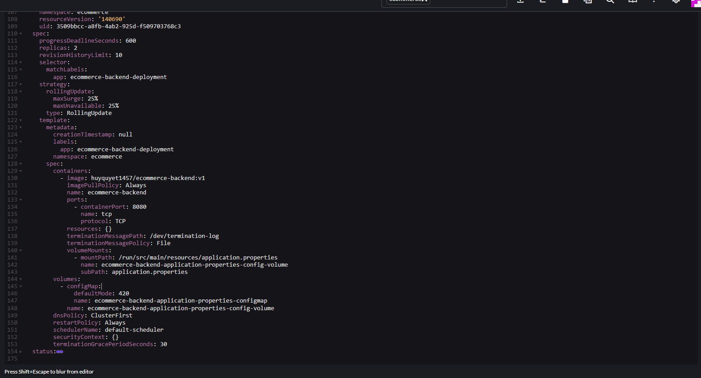
- Tao 1 volume de co vi tri luu tru du lieu cua config map, thang hang voi containers
- Trong container tao ra volume mount, mount gia tri vua tao vao ben trong container o thuc muc /run/..

